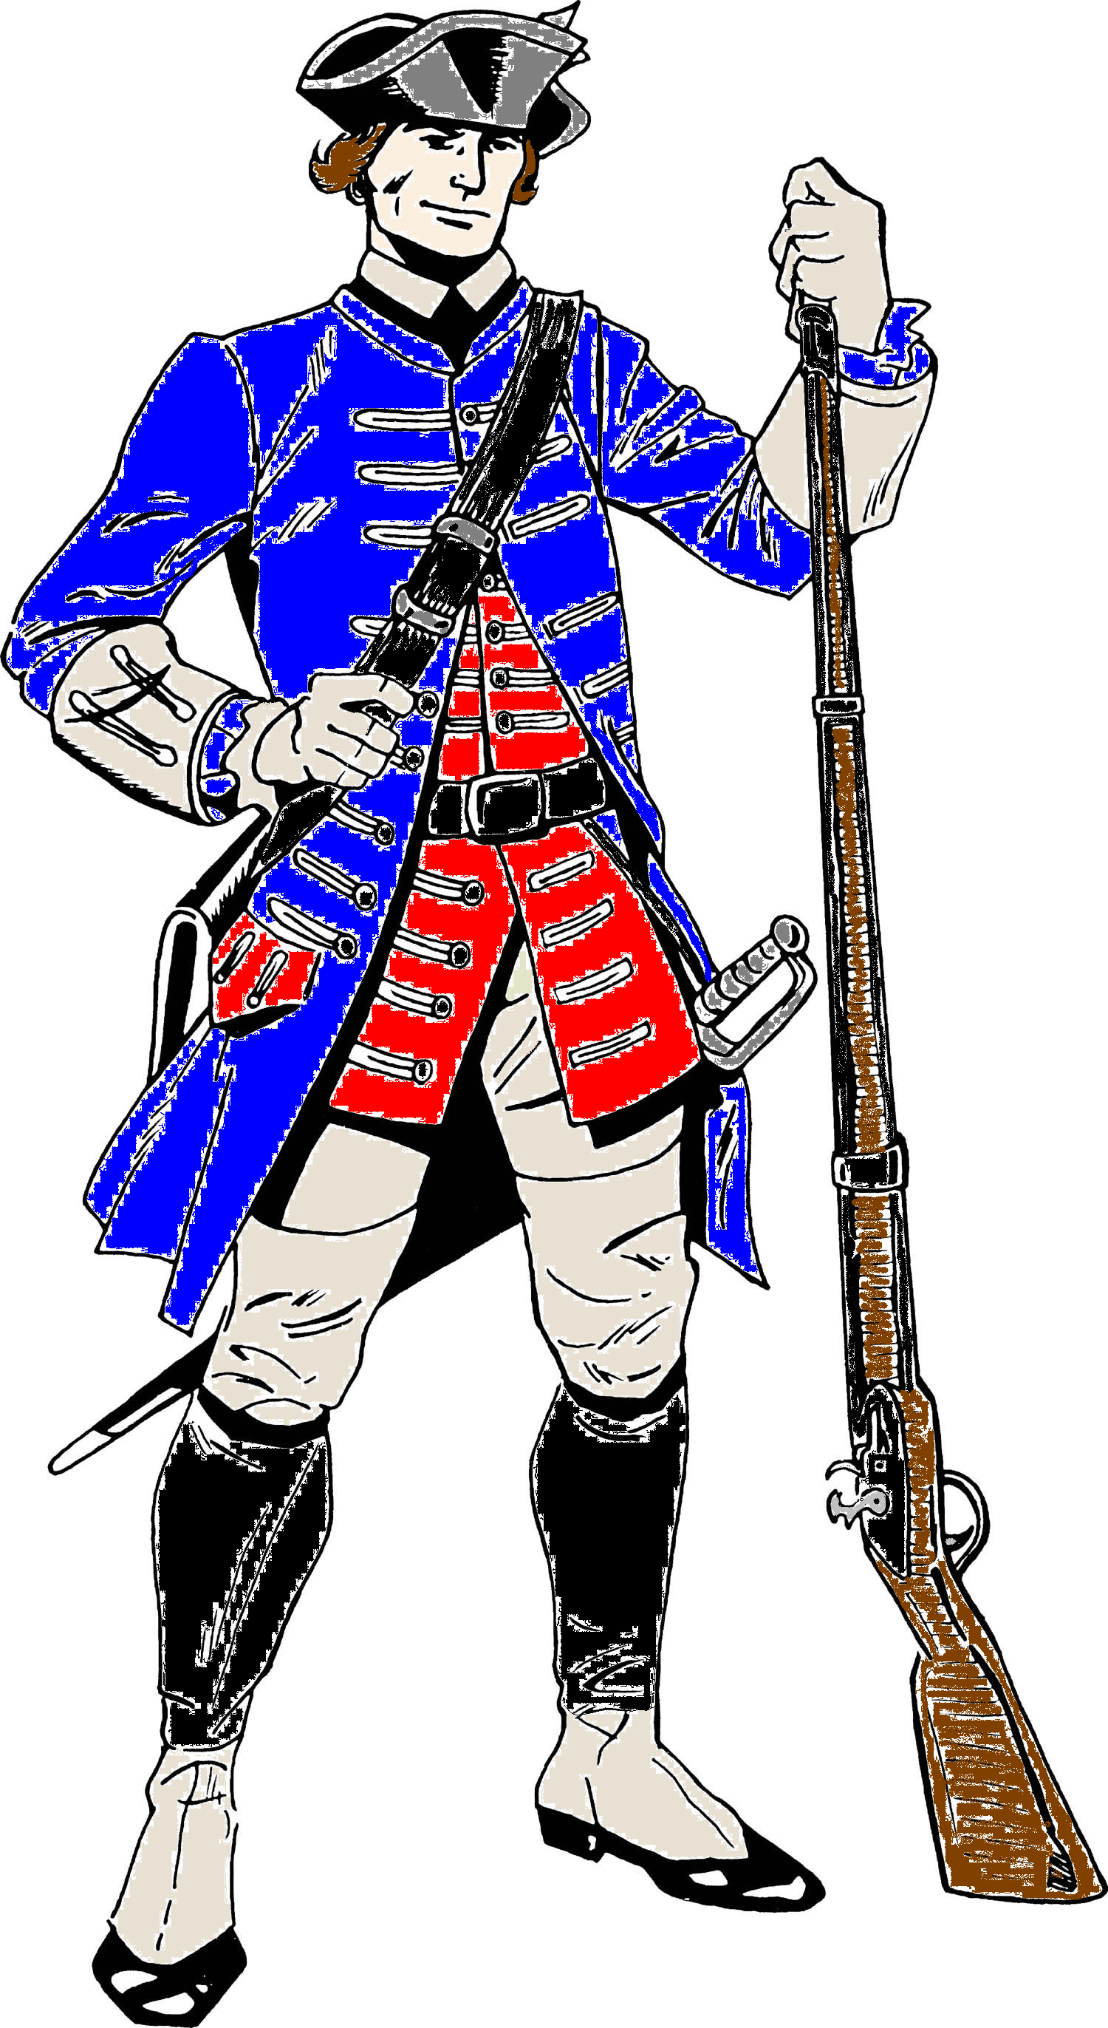
Allen County Schools
[Type the company address]
08
Fall

Richard Elmore
Windows of Common Practice
Efficacy & High Expectations + Efficacy & High Expectations
Efficacy & High Expectations + Efficacy & High Expectations
Efficacy & High Expectations + Efficacy & High Expectations + Efficacy & High Expectations
Efficacy & High Expectations + Efficacy & High Expectations + Efficacy & High Expectations
Instructional Goals & Best Practices
Patriots are
Certified for Life

Relationships & Classroom Learning Environment
Outcomes for All Students | ACS Instructional Goals | ACS Continuum of Best Practices  Performance Descriptors Effect Size .72
Work with others in a respectful and cordial manner. | Students develop social awareness and self -regulation strategies in order to function productively within a team. | Students use acceptable vocabulary and respectful tone when working together.  Students self-reflect on how they are working with peers.  Routines are established to support smooth transitions within the class.  Students listen to others as they share ideas & information.
Recognizes authority and respects the needs of others. | Students follow classrooms procedures and expectations. | Student behavior is monitored.  Inappropriate behavior is corrected.  Students follow classroom procedures, expectations, & structure.  Student and teacher interact respectfully.  Classroom expectations are clear.
Contributes to the larger community to support its development. | Students are active in helping maintain an environment for learning. | Students are involved in the establishing behavior & learning expectations.  Students monitor self & each other’s behavior and support when needed.  Student leadership opportunities provide for smooth classroom operations.  Students elaborate and build on each other’s’ ideas.  Students recognize the abilities and ideas of others.
Develop a strong work ethic and takes pride in doing a job well. | Students exhibit high expectations for their classroom performance. | The teacher insists that students put forth their best effort.  Students work on the task provided without wasting time.  Student exemplary work is displayed.  Supports the idea that hard work leads to improvement and success.  Students persist on tasks even when they are difficult.
Set high expectations that challenges oneself to be their very best. | Accept that all students can learn despite challenges and that it is up to the instruction & support we provide and not outside factors that determine success. | Expect critical vocabulary to be used when discussing school work.  Expect students to write and speak using complete sentences. (Grades 1 – 12)  Hold the same high expectations for all ability students  Maintain an unwavering belief that they will prevail will all their students.  Develop as a professional – continue to learn and refine teaching practices.  Do everything in their power to ensure that their students are successful.  Refuse to blame students for not learning. Look for tools and strategies to overcome. Expect students to do school work and take measures to correct when they don’t.
School is Fun! | Classroom time is an enjoyable experience where students feel safe, are able to laugh, be curious and engage in the wonders of learning new things. | Classroom is visually appealing.  Arrangement allows for time and place to think, explore, and work with others.  Interactions among teacher and students are spirited and respectful.  Though focused, people are smiling and interacting when appropriate.  Classroom members share mistakes and failures in solving tasks.  Teacher displays excitement about what is being learned and encourages students to be equally engaged.

Developing Ownership & Independence
Outcomes for All Students | ACS Instructional Goals | ACS Continuum of Best Practices  Performance Descriptors |  | Effect  Size
Ask questions as a means of understanding a concept or problem. | Open questions are posed by the teacher that elicit thinking. Students ask content relevant non-procedural questions to peers & teacher. | 3B Poses open-ended questions that promote discussion.  3B Probes student responses to stretch thinking.  3B Acknowledges student thinking through paraphrasing.  3B Students ask questions and pose new ones.  3B Asks questions to drive inquiry for the lesson and unit.  3B Set and defend a high standard for answering questions: Use no opt out, wait time, cold & warm calling, and Talk Moves strategies consistently |  | Discussion/  Discourse  .88  Questioning  Teacher .48  Self .64
Engage in meaningful discussions and use effective communication skills to work with others to identify and solve problems. | Students are engaged in authentic discussion/discourse with peers. | 3B Uses protocols to guide group conversation.  3B Engages students in discourse with partners & small groups.  3B Provides opportunities for student leadership of discussions.  3B Students build on each other’s ideas.  3B Holds students accountable for their learning from discussion. |  | Discussion/  Discourse  .88
Persevere through challenging problems and situations by using various strategies and techniques.  Are aware of how they learn best and use that knowledge to pursue personal success.  Develop the ability to connect how new learning opens doors to new opportunities. | Lessons are designed using the workshop structure:  - Explain/Model skills & content that students need help with. (Includes catch & release).  - Work time in singles, pairs, groups around a cognitively demanding task.  - Reflection Time to gather and share information and connect to critical learning. | 3C Conducts an opening & mini lesson using modeling & think aloud to explain new learning, develop a skill, or complete a task.  3C Provides a block of work time for students to work individually, in pairs or small group to read, write, talk, & think. (Guided Practice)  3C Provides clear expectations and appropriate support to ensure students use time well.  3C Encourages self-sufficiency & allows productive struggle.  3C Confers with student/groups to monitor learning. (ask questions, provide instruction, collect evidence)  3C Inserts “catch & release” to respond to patterns/issues found with student thinking.  3C Differentiates instruction as needed.  3C Ask students to reflect on what they have learned and why it matters. (Reflection & Metacognition)  3C Provides opportunities/structures for students to hold & retrieve their thinking. (Anchor charts, KWL, etc.)  3C Models ways thinking can support understanding & identifies (notices) in self and students when appropriate. |  | Modeling  Direct Instruction – Gradual Release  .59  Productive Struggle  .64  Metacognition  .69

Using Goals & Results to Drive Improvement
Outcomes for All Students | ACS Instructional Goals | ACS Continuum of Best Practices  Performance Descriptors |  | Effect  Size
Connect each new experience to their existing knowledge.  Determine what must be done to complete a task/job successfully. | The content/habit target, criteria for success, and relevance are presented to students throughout lessons as appropriate. | 3A Explains learning targets and connects them to relevance.  3A Connects targets to prior and future learning.  3A Provides opportunities for students to reflect/discuss learning targets before, during and after lesson.  3A Ensures that students can articulate what success will look like when targets are mastered. |  | Learning  Targets  .41  Teacher  Clarity  .75
Set goals for improvement based on an understanding of individual strengths and weaknesses. | Students are provided opportunities to self-assess their strengths and weaknesses around current content and skills being learned. | 3D Provides structures for students to self-assess their progress of achieving targets/standards.  3D Students have ongoing opportunities to self-assess/track progress.  3D Students help define success for learning when  appropriate. (rubrics, anchor charts, etc.) |  | Assessment  Capable  Learner  1.44
Monitor for meaning as they learn in a variety of situations. | Informal assessment information is collected from a variety of sources and is used to maximize learning during class time. | 3D Information (what you hear & see kids saying, doing, writing, etc.) is gathered before, during, and/or after the lesson.  3D,E Modifies instruction before, during, and/or after the lesson based on informal assessment information.  3D Students are provided time to monitor their own clarity about the content/topic/skill. |  | Metacognition  Monitoring & Evaluating learning  .69
Provide situation feedback to others that helps them move forward and use feedback they receive to improve themselves. | Feedback is provided by teachers and students to clarify learning and support ownership of next steps. | 3D Offers feedback in a timely manner that assists learning.  3D Notices and names productive learning behaviors.  3D Documents individual progress and uses to inform next steps.  3D Provides opportunities for students to offer feedback to peers. |  | Feedback  .75
Assess their progress toward goals and adjust accordingly. | Common formative and summative assessment data is collected regularly from a variety of sources and is analyzed to improve student performance. | 3D Assessments are aligned to rigor of standards.  3D Uses common formative assessments to monitor progress  and modify instruction.  3D Analyzes students’ progress toward mastery of the standards across the grade level.  3D Tracks student progress toward mastery of standard. |  | Formative A.  .70

Relevant & Challenging Instruction
Outcomes for All Students | ACS Instructional Goals |  | Effect Size
Students receive equivalent learning opportunities. | All students have access to the same content, knowledge and skills in each section or class. |  | Guaranteed & Viable Curriculum  .88
Learn strengths and weaknesses about themselves as thinkers and learners. | Create opportunities for metacognition as part of daily, weekly, monthly, reflection.  Tap into students’ background knowledge to identify misconceptions before providing new instruction. |  | Metacognition  .69
Effectively communicate  through writing for a variety of purposes. | Non-fiction writing in all content classes is used throughout  every unit and assessment. Examples: constructed response, lab reports, argument, & writing to learn. |  | Writing  .82
Can understand others and express their own ideas and opinions. | Systematic vocabulary instruction is provided to all students in each subject area for each unit of study and individual lessons as appropriate. |  | Vocabulary  Instruction  .67
Display confidence in their ability and are not afraid of mistakes or the need to struggle in a quest for improvement. | Learning experiences include high cognitively demanding tasks  (DOK 3+ and Bloom Apply+) in all units and individual lessons as appropriate. |  | Cognitive Demand  (organizing, elaborating, planning, evaluation)  .75
Prioritize information and make inferences that lead to new understandings. | Students use literacy strategies to make sense of a text or  problem and can identify how the strategy helps them learn. |  | Comprehension  Strategies  .72
Exhibit the qualities of good workers and successful people. | Each classroom focuses on developing mindsets of good workers/learners. Thinking, Self-Awareness, Resilience, Work Ethic) |  | Self-Efficacy  .80

Collaborative Professional Learning
Outcomes for Teachers | ACS Instructional Goals | ACS Continuum of Best Practices  Performance Descriptors
Teachers are supported with structure and time to meet with colleagues to make instructional plans that are consistent across the grade and content. | Teachers participate in collaborative development of same grade level & course instructional units that have common standards and assessments. | 4D Teacher actively participates and or takes a leadership role in promoting a culture of professional inquiry.  4D Teacher seeks out opportunities for professional development and makes a systematic effort to conduct action research.  4D Teacher welcomes colleagues and supervisors into the classroom for the purpose of gaining insight from their feedback.  4D Teacher welcomes feedback from colleagues in individual and collaborative settings.  1F Formative assessment is well designed and includes student as well as teacher use of the assessment information. Teacher intends to use assessment results to plan future instruction for individual students.  Teacher participates in a collaborative process to review students’ progress toward standards by providing their student data, work samples, instructional strategies, etc. as needed/required by the PLC data team.
 | Teachers participate in collaborative reviews of instructional units and make adjustments as needed.
Increased communication and collegiality within & between grade levels. | All teachers annually participate in collaborative observation and analysis of instructional practice to study impact on student understanding and achievement. (Lab Classes, Lesson Study, etc.). Effect Size – 1.57
Build efficacy through opportunities to study first hand, effective practices that elicit improved student performance.
Aware of the impact their instruction is having on student performance. | All teachers and administrators collaboratively review student performance data (tests, exit slips, anecdotal notes, student work, etc.) & use it to collaboratively make instructional practice decisions that increase achievement. Effect Size - .90
Choice is provided for teacher continuous self-improvement that is flexible and responsive for teachers’ current needs/interests. | All teachers self-assess their practices as an ongoing process for continuous improvement and will monitor their progress with the support from instructional coaches, peers and administrators.

1. Increase the level of knowledge and skill that the teacher brings to the instructional process. | 2. Increase the level and complexity of the content that students are asked to learn. | 3. Change the role of the student in the instructional process.
3 ways to ensure students learn. Richard Elmore

